Terms of Reference: HPRU EZI Knowledge mobilisation working group

The NIHR Health Protection Research Unit (HPRU) in Emerging and Zoonotic Infections (EZI) knowledge mobilisation (KM) working group is a collaborative group that supports the KM lead with the implementation of the KM strategy. The working group will keep oversight of the wider KM programme and works on an organisational level. The KM lead chairs the meetings and is also a member of the Unit’s steering committee and management team (figure 1). During the working group meetings they will, where feasible, represent the whole working group, supported by the programme manager, and raise any issues the group identified at the relevant level.
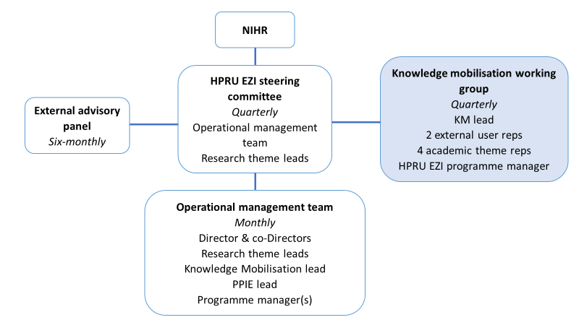
Figure 1: Governance structure of NIHR HPRU EZI

The working group will meet quarterly. The group will consist of:
- The KM lead
- Academic representatives from each research theme (4 total)
- External user representatives (2)
- The HPRU EZI programme manager (observer)

The working group members support and work closely with the KM lead. The working group has several objectives:
- Monitor the execution of the KM strategy
- Provide feedback on matching research objectives with user needs
- Provide feedback and KM insights on ongoing work within the HPRU EZI
- Reflect on annual reporting data
- Support the training and development of PhD students and early career researchers within the HPRU EZI

